Lab exam

Question 1

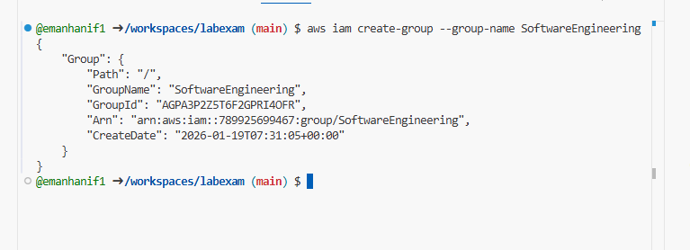

View group details (name + ARN)

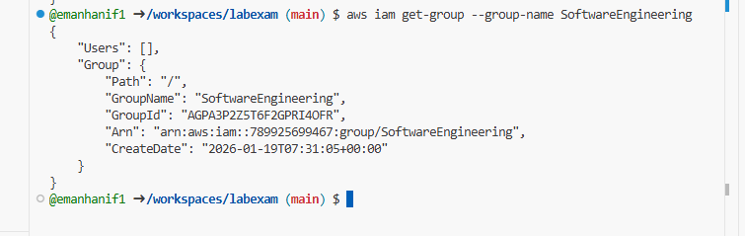

Part2:create IAM User (AWS CLI)

Create IAM user

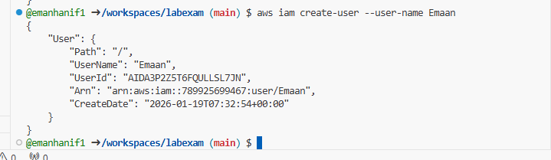

View IAM user details

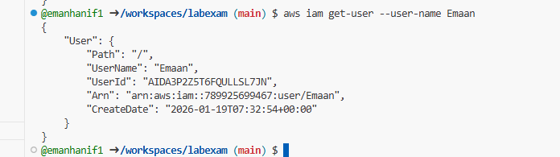

Part 3: Add User to Group

Add user to SoftwareEngineering group

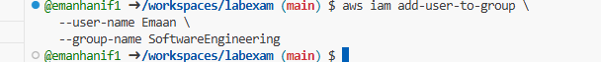

Confirm group membership

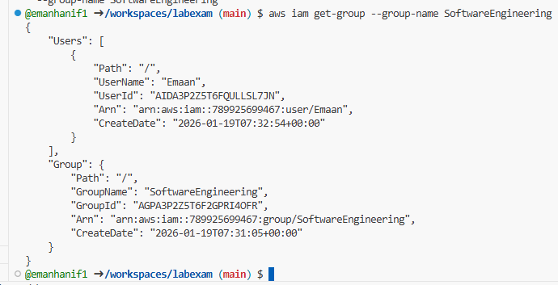

Part 4: Attach AdministratorAccess Policy

Find AdministratorAccess policy + ARN
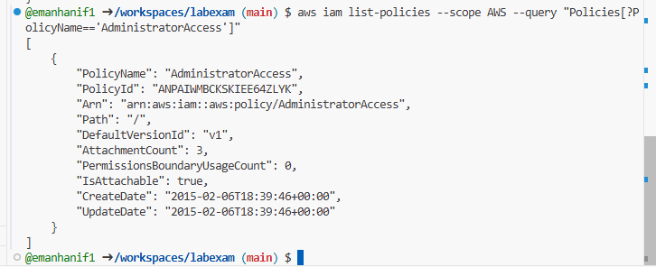

Attach policy to group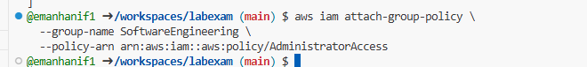

list attached policies for the group
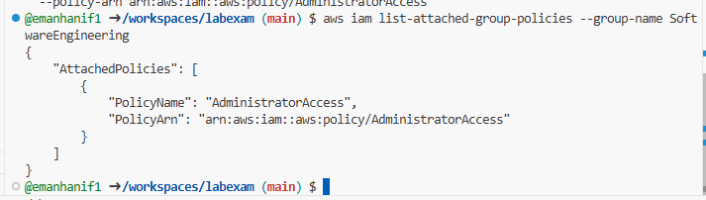

Part 5: AWS Management Console Verification

We will Go to:
AWS Console → IAM → User groups
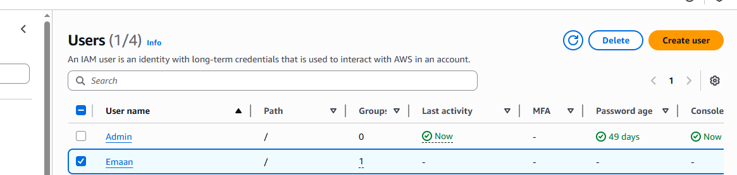

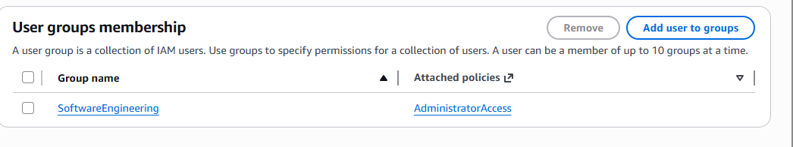

q1_console_group

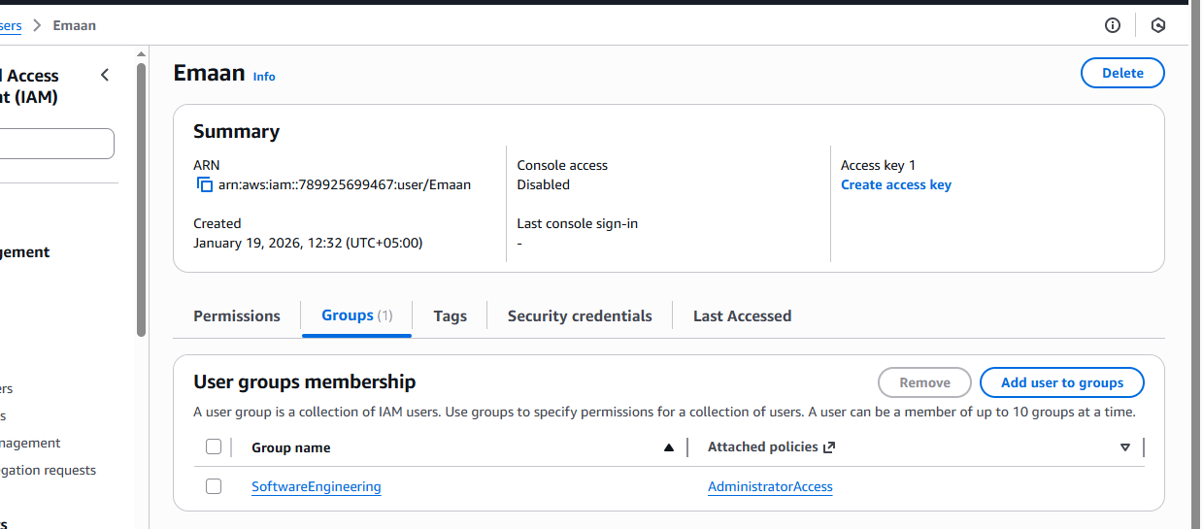

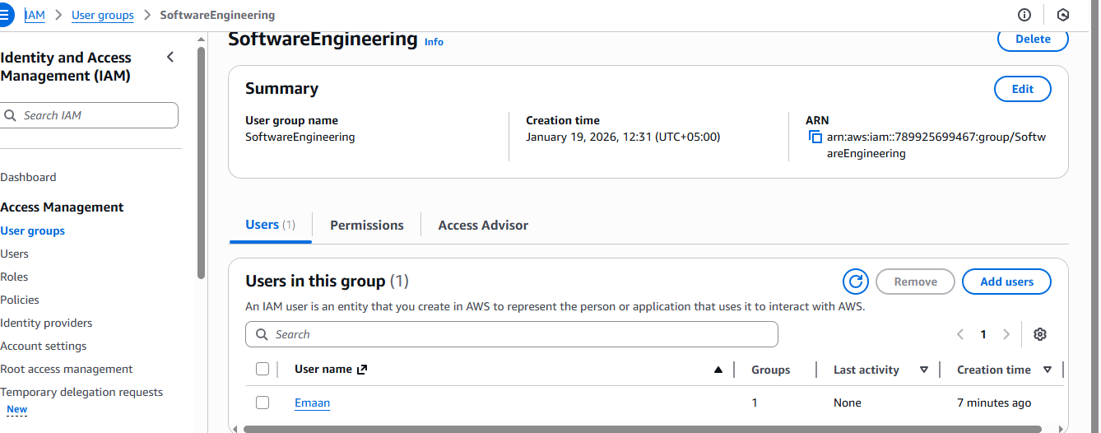

q1_console_user_in_group.png

Policy attached
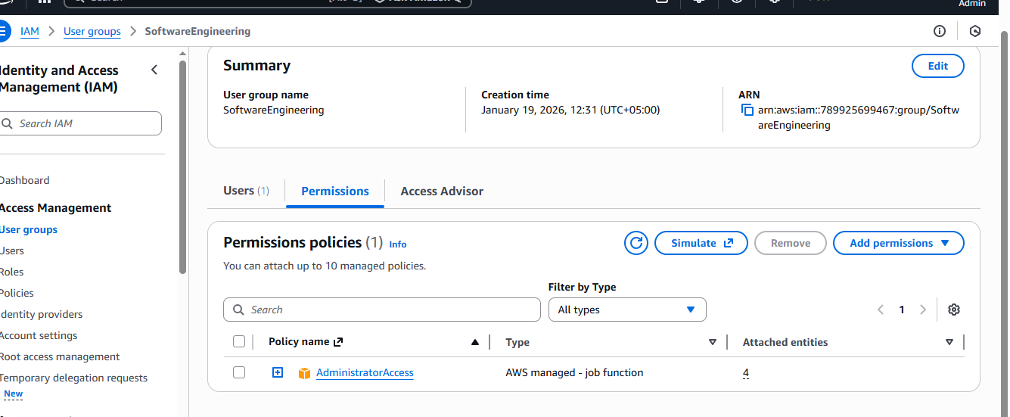

Question 2

Main.tf

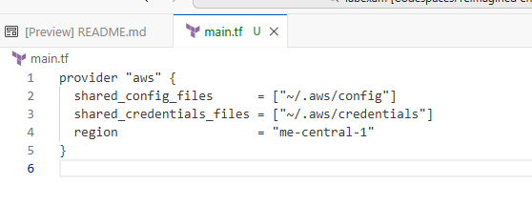
STEP 2: Define Input Variables

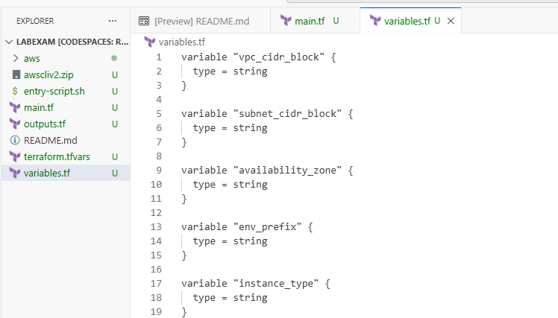

VPC + Subnet

main.tf
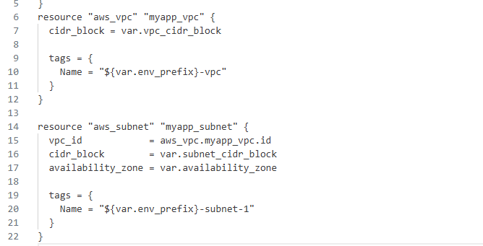

Internet Gateway + Default Route Table

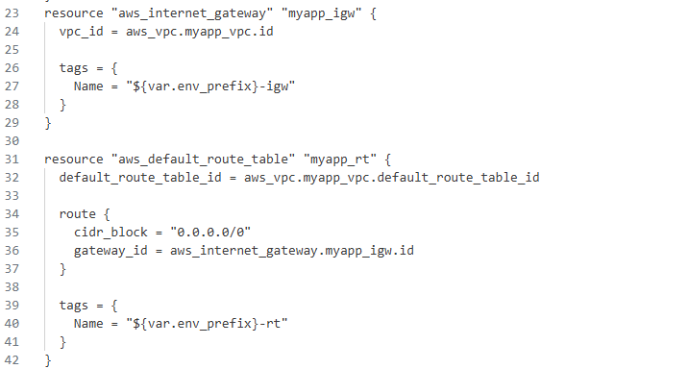

Public IP Discovery using data "http" + locals

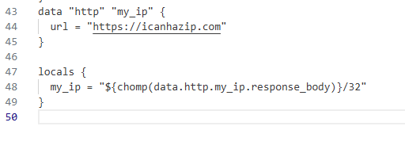

Default Security Group Configuration

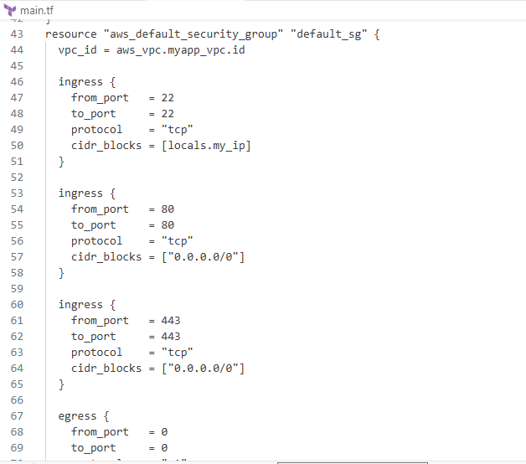
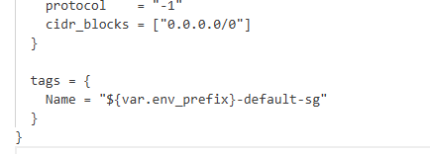

AWS Key Pair

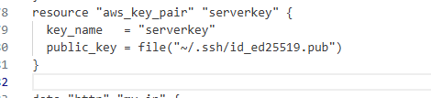

EC2 Instance Resource

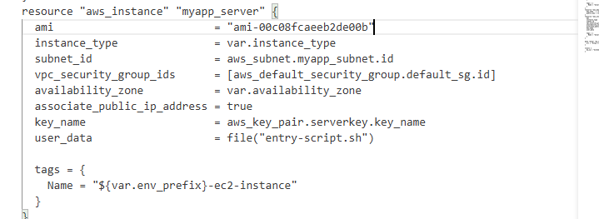

entry-script.sh (Nginx + HTTPS) entry-script.sh

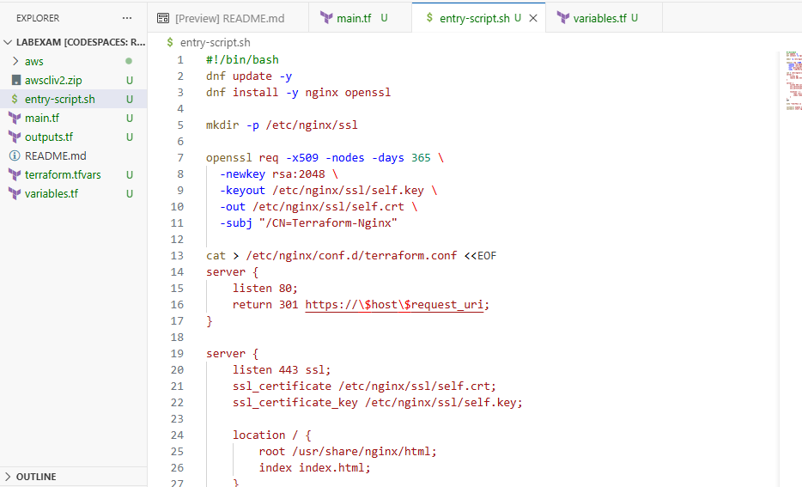

Make it executable

Terraform Output

outputs.tf

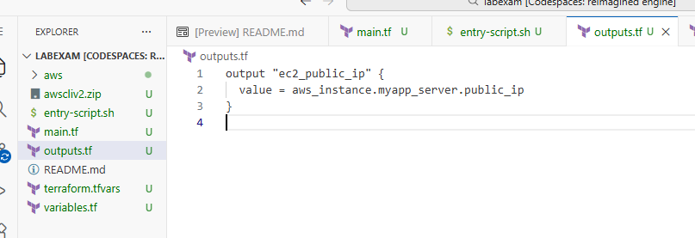

Variable Values

terraform.tfvars

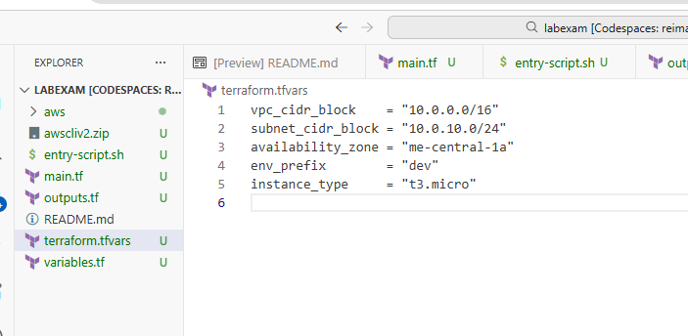

Terraform Commands
Terraform init

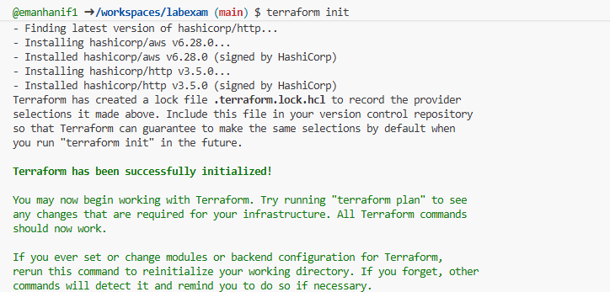

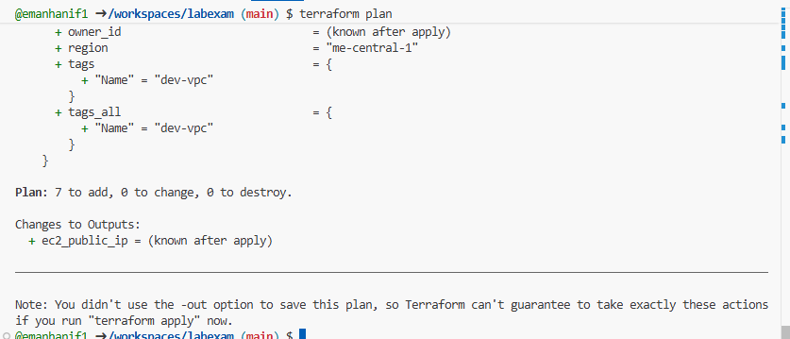

Terraform apply

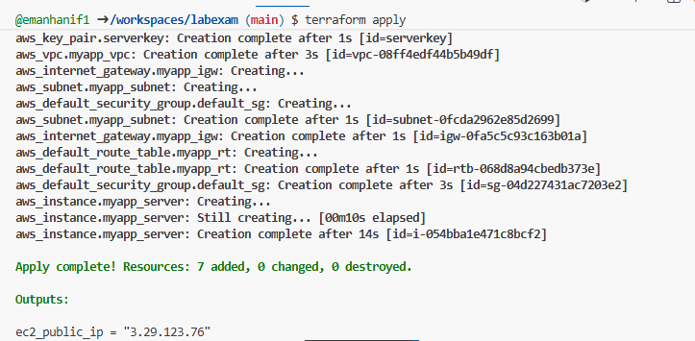

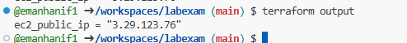

On console

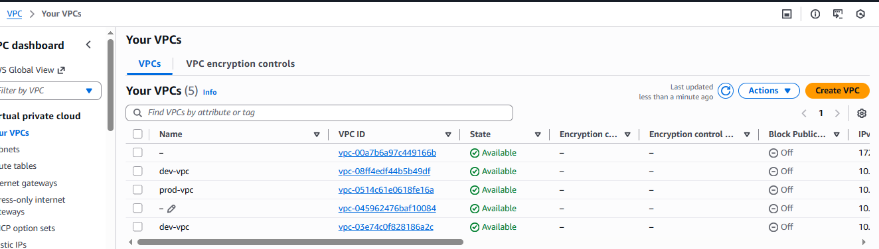

Verify Subnet

Steps
- VPC → Subnets
- Click subnet dev-subnet-1
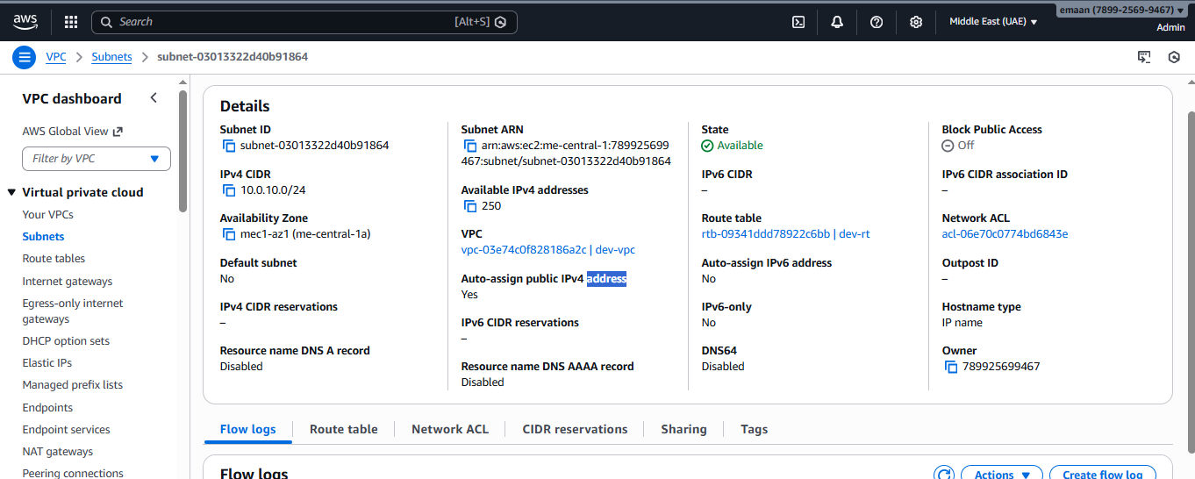

Verify Internet Gateway

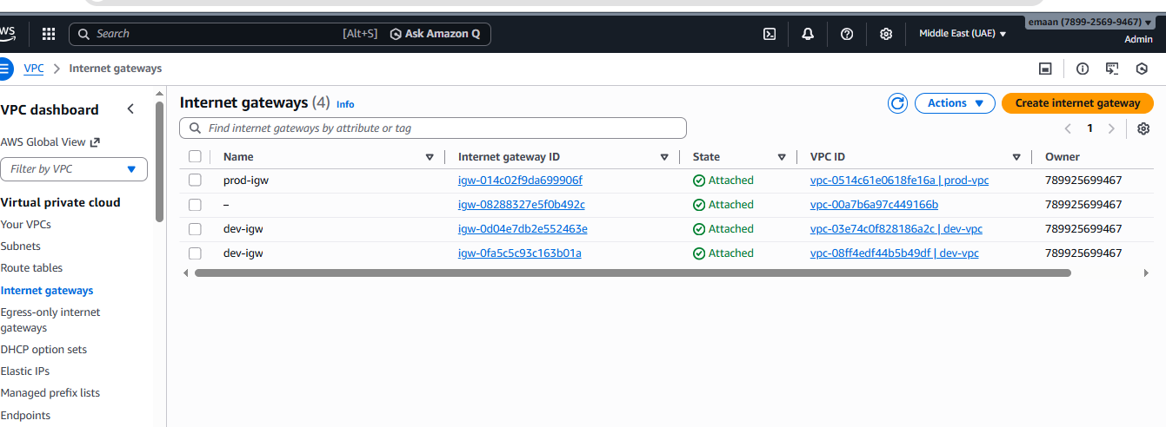

Verify Route Table

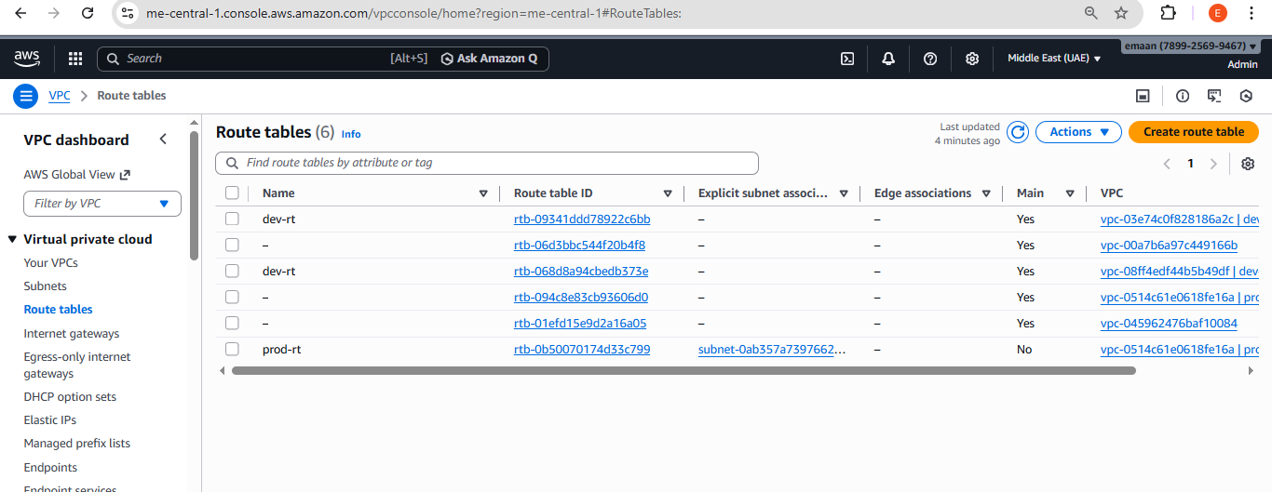

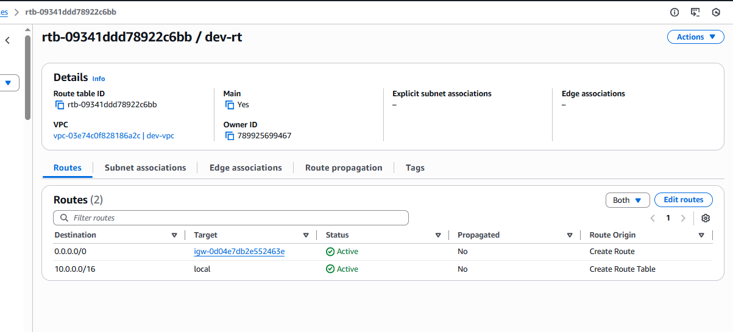

Verify Security Group (DEFAULT SG)

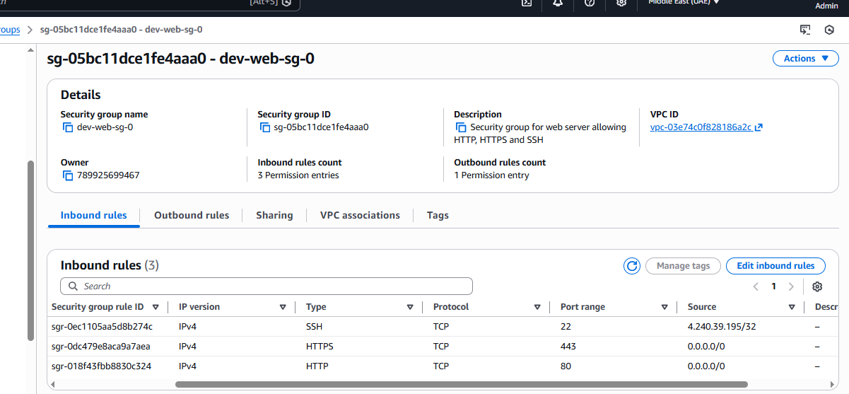

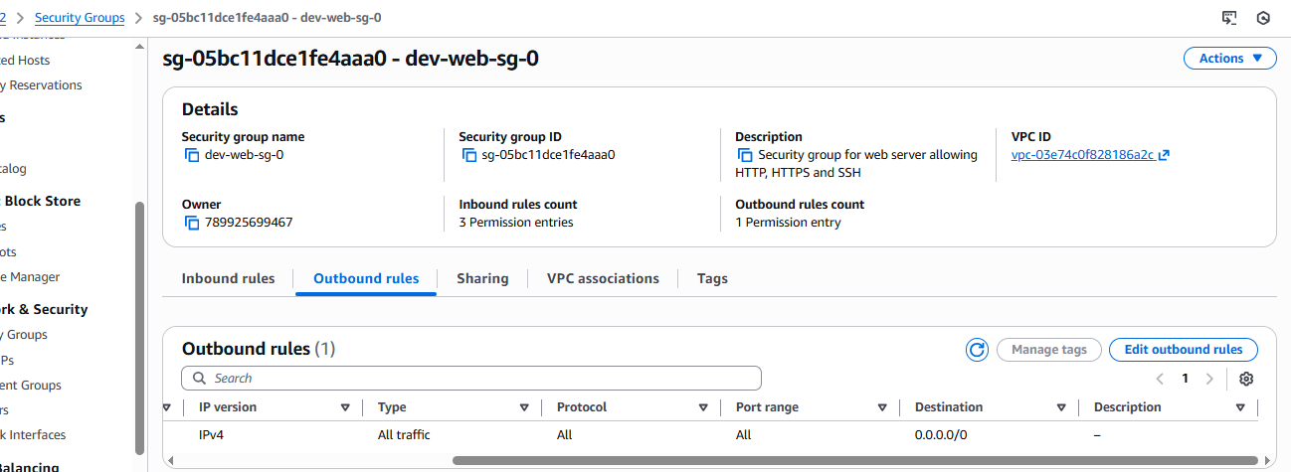

Verify EC2 Instance

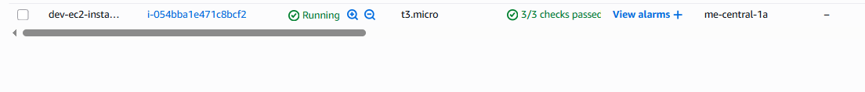

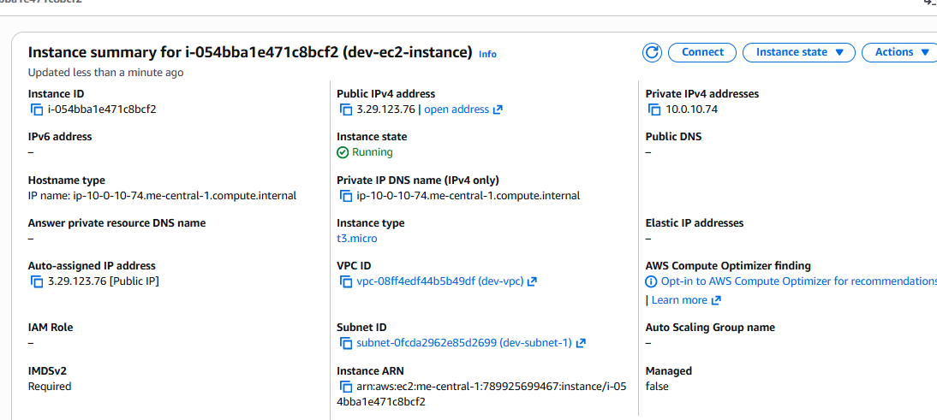

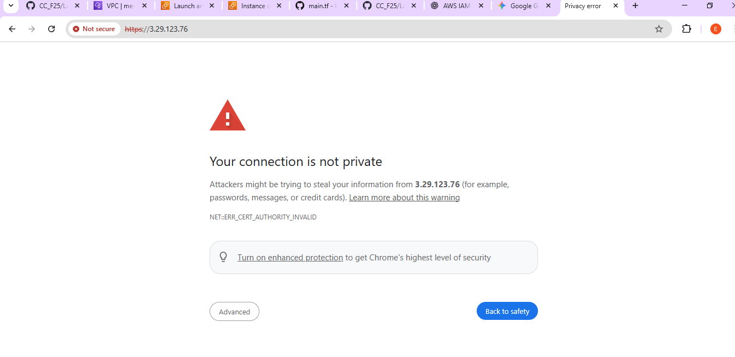

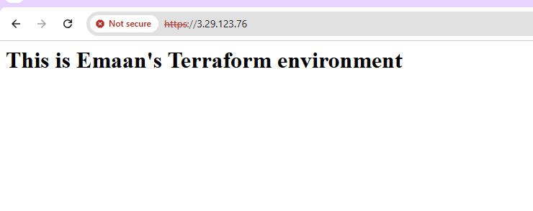

Question 3

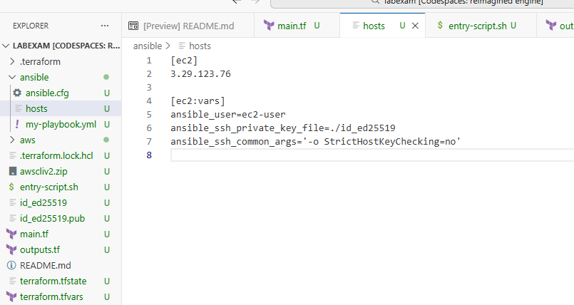

q3_hosts.png

Place your private key here

Private key having correct permissions

ansible.cfg

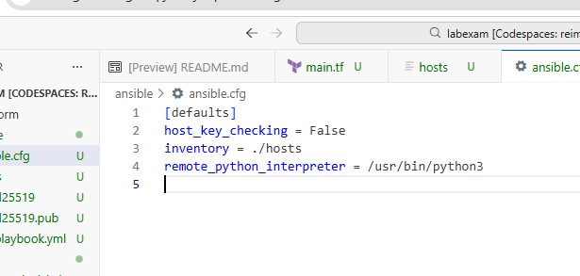

q3_ansible_cfg.png

my-playbook.yml

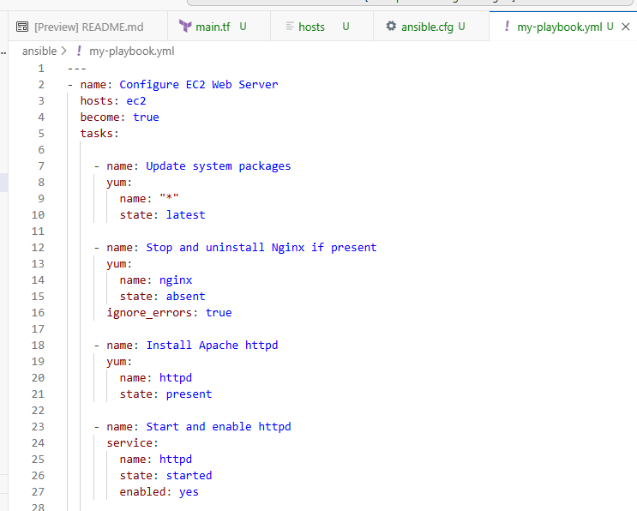

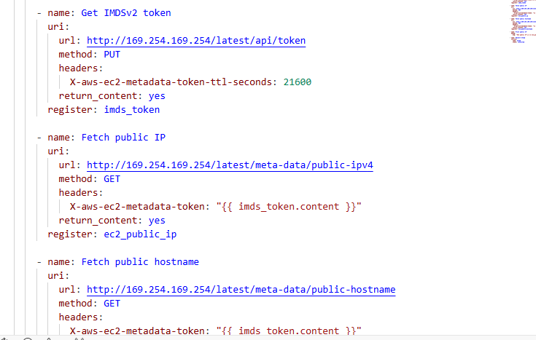

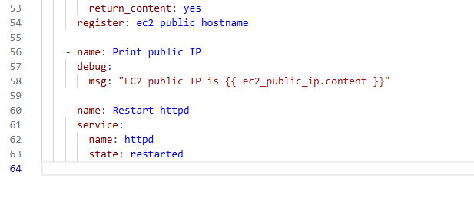
q3_playbook.png

Run the playbook
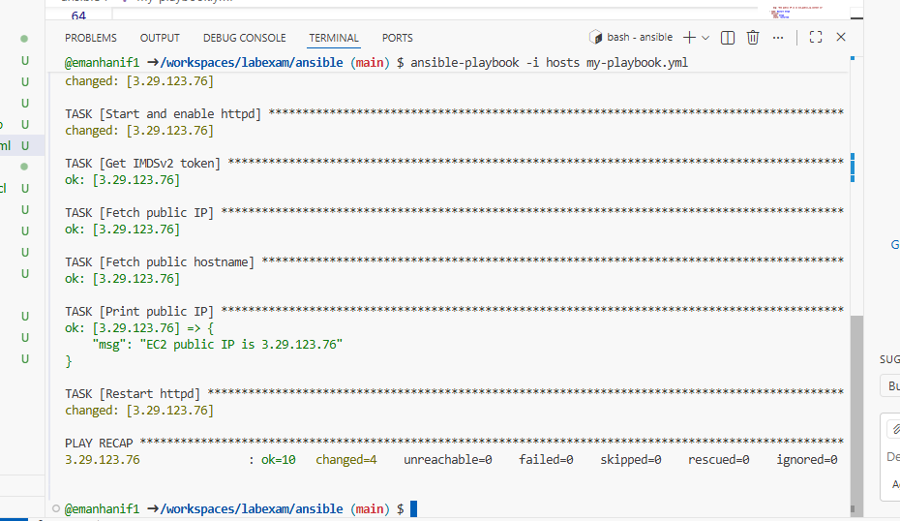

q3_play_run.png

Verify HTTP

see the Apache default page

http://<public-ip>
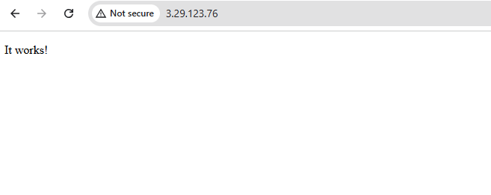

q3_http_browser.png

The "It works!" page is the default Apache page

I have successfully reached the Apache (httpd) default page

